

In association with
EURASIP
and
Slovak University of Technology, Bratislava, Slovak Republic
and
Association of telecommunication users in Slovakia

General Chair
Gregor Rozinaj
Slovak University of Technology, Bratislava, Slovak Republic

Program Chair
Pavol Podhradský
Slovak University of Technology, Bratislava, Slovak Republic

Contact information
Gregor Rozinaj
IWSSIP
Faculty of Electrical Engineering and Information Technology
Ilkovičova 3
812 19 Bratislava
Slovak Republic
Phone: +421 2 682 79 414
Fax: +421 2 602 91 763
E-mail: iwssip@iwssip.stuba.sk
Web: iwssip.stuba.sk

Important dates
Full paper to be received by
March 14, 2008
Notification of Acceptance
April 12, 2008
Early registration
April 14, 2008
Camera ready paper to be received by
April 18, 2008
Registration deadline
May 31, 2008




15th International Conference on Systems, Signals and Image Processing
IWSSIP 2008
June 25 – June 28, 2008, Bratislava, Slovak Republic
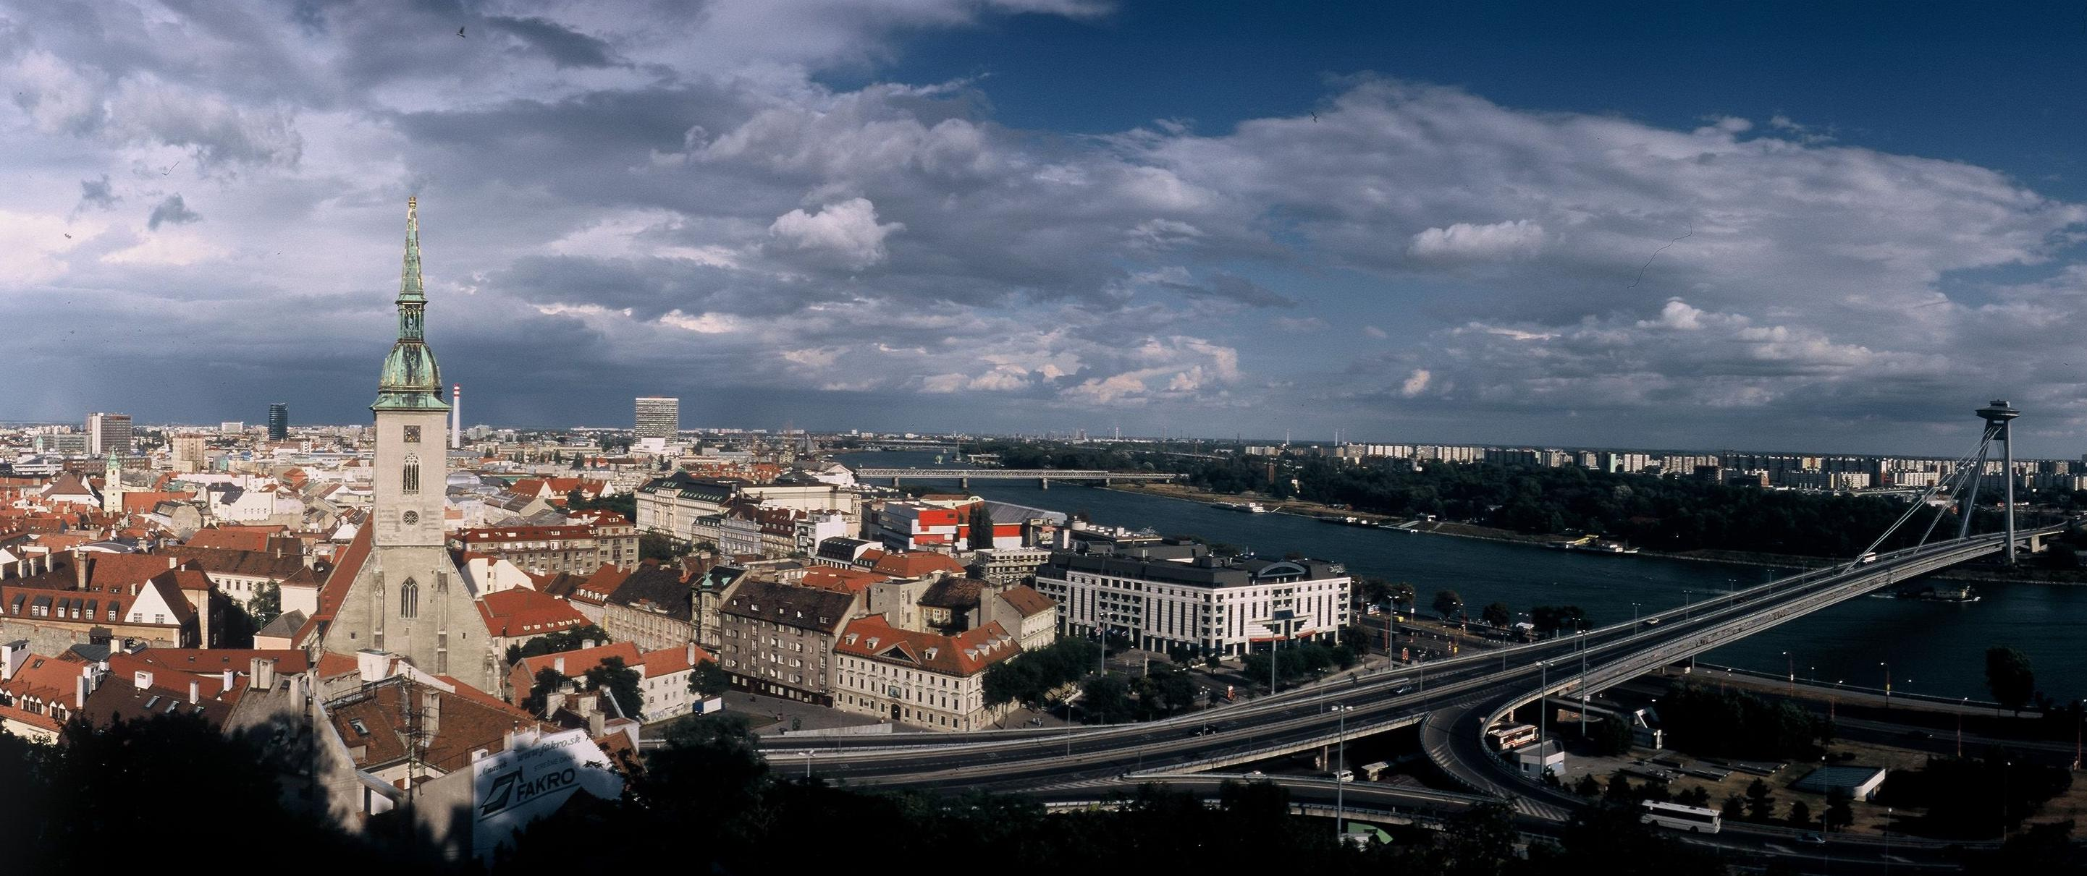
Call for papers

The 15th International Conference on Systems, Signals and Image Processing, IWSSIP 2008 will be held in hotel Nivy*** in Bratislava, Slovak Republic, during June 25 – June 28, 2008. IWSSIP 2008 follows the successful events previously held in Budapest, Manchester, Poznań, Zagreb, Bratislava, Maribor, Bucharest, Prague and Chalkida. IWSSIP brings together researchers and developers from both academia and industry to report on the latest scientific and theoretical advances, to discuss and debate major issues and to demonstrate state-of-the-art systems.

Topics of interest
The program includes keynote and special lectures presented by eminent experts in the field, peer reviewed contributed papers, posters, invited sessions on the same or related topics, industrial presentations and exhibitions about but not limited to the following topics for IWSSIP 2008 conference:
Submission of Regular Papers:
- Signal Processing and Systems  - Artificial Intelligence Technologies  - ICT in E-learning/Consulting  - Video Streaming and Videoconferencing  - Watermarking and Encryption  - Speech and Audio Processing  - Image and Video Processing and Coding  - Multimedia Human-Machine Interface and Interaction  - Multimedia Content Processing and Content Description  - Multimedia Signal Processing  - Multimedia Databases | - Multimedia Communications, Networking, Services and Applications  - Multimedia Data Compression  - Multimedia Systems and Services  - Information and Network Security  - IMS based NGN Architecture, Services and Protocols  - Mutimedia Services in NGN  - DVB and IPTV Technologies  - Multicast & Broadcast for IPTV  - Service Control and Media Delivery in NGN based IPTV  - Service Selection and Discovery for Multimedia Services  - Next Generation Mobile Networks  - Fixed Mobile Convergence
Prospective authors are invited to submit full-length, four-pages long papers, including figures and references. Papers must be submitted electronically by March 1, 2008. Each paper will be reviewed by at least two independent reviewers, and will be accepted based on its originality, significance and clarity. Please note that the submission dates for papers are strict deadlines.

Publications:
All accepted papers will be published in Proceedings that will be available at the conference. Extended and enhanced versions of selected papers will be published in scientific journals, as well

Conference fees:
The payment methods will be updated later.

• Early Registration (before April 14) 380 €
• Regular Registration 450 €
• Student Registration 180 €
IEEE members receive a 50 € discount off the list price

iwssip.stuba.sk

